Create a aws machine with one instance.



Connect to aws instance with the gitbash terminal

Update the apt repository

Sudo apt-get update

Install tomcat9

Sudo apt-get install tomcat9 -y

Install tomcat9 admin

Sudo apt-get install tomcat9-admin

Check the tomcat is working or not -->take the public ip of sit server and add port no 8080

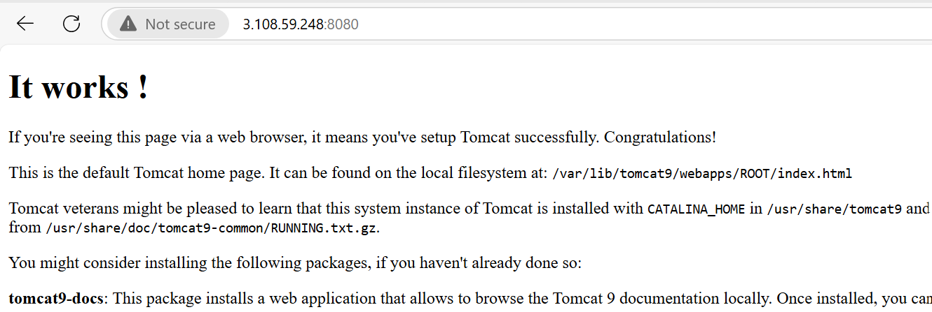

cd /etc/tomcat9

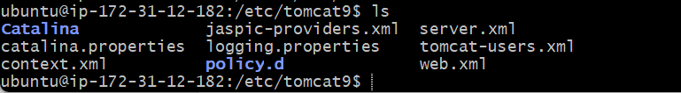

sudo vim tomcat-users.xml

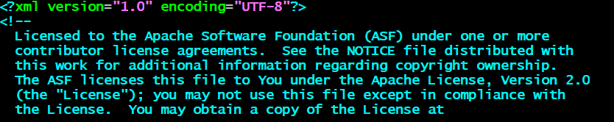



Restart the service

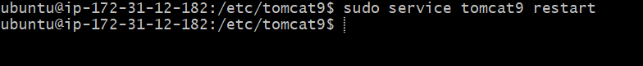

Start the jenkins

Add the deploy to container plguin

Manage jenkins-->availble-->deploy to container install it

